Trenitalia ETR600 Eurostar Italia ‘Frecciargento’
Venice – Bologna - Florence – Rome & other routes
(Some services operated by ETR600, some ETR480, see below)

Seat numbering plan…

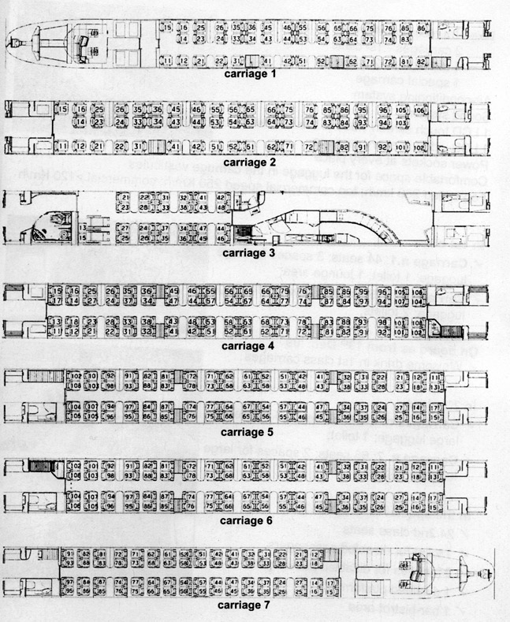
Plan provided courtesy of Trenitalia – book these trains online at www.trenitalia.com
Trenitalia ETR485 / ETR460 Eurostar Italia ‘Frecciargento’
Venice – Bologna - Florence – Rome, Rome to Bari, Verona, Lecce & other routes
Seat numbering plan…
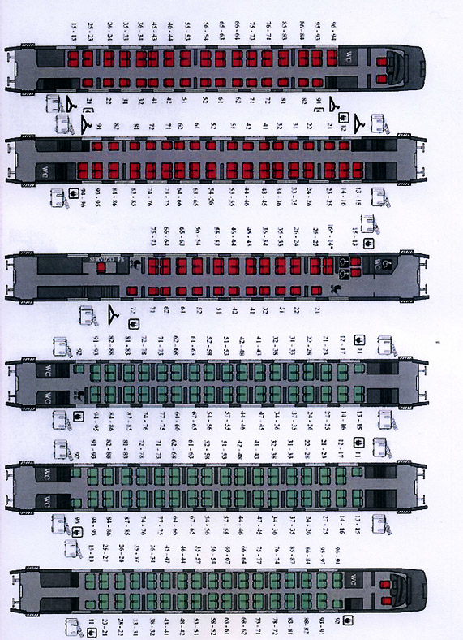
Plan provided courtesy of Trenitalia – book these trains online at www.trenitalia.com

