Trenitalia ETR500 Eurostar Italia ‘Frecciarossa’
Turin - Milan – Bologna - Florence – Rome - Naples

Seat numbering plan (car 5 is the bar-restaurant car)

Cars 1, 2 & 4 (1st class): Car 3 (1st class): Cars 6 to 12 (2nd class):

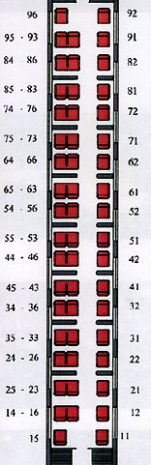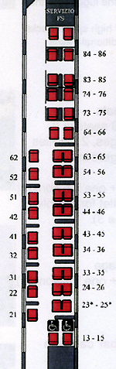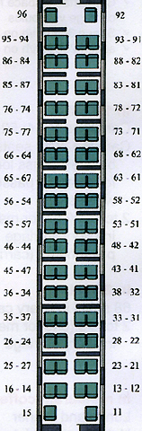

Plans provided courtesy of Trenitalia

