CD (Czech Railways, blue) Railjet trains.
All cars have toilets, all seats have 230v power sockets. Suitcase symbol = large luggage rack.
Some Prague-Vienna departures are operated by Austrian (red) railjets with different interiors.
<<<< direction of travel from Vienna to Prague
Direction of travel going from Prague to Vienna >>>>>>
Car 21 - 2nd class.
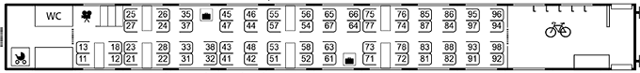
Car 22 - 2nd class
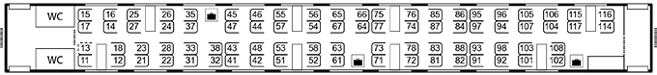
Car 23 - 2nd class
Car 24 - 2nd class
Car 25 - 2nd class
Car 26 - 1st class & restaurant
Car 27 - business class (= premium 1st) & regular 1st class.
